Revolution through Art
Part I: In Groups: On a separate sheet of paper try to identify what each painting is about. Who are the people? What colors are used? What sort of imagery is used?

Part II: Individually:
You are a revolutionary artist in Mexico who has been inspired by the works of Diego Rivera. You have decided to create your own mural based on your knowledge of Mexican history and the revolution.

Before you draw your mural be sure to consider the message your artwork will send. Do you favor a revolt like the Bolsheviks? Perhaps a return to more traditional Aztec living? Do you admire the achievements of the U.S, or do you detest the Americans?

After you have completed your mural, you will need to prepare a brief (one paragraph) explanation of your mural detailing its overall message(s), your use of imagery and why you chose such images.
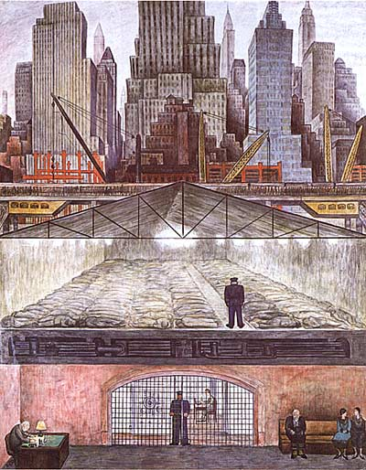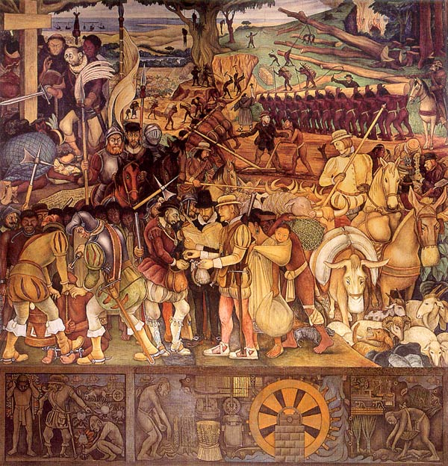
Frozen Assets Disembarking Veracruz
